 | Quang Thanh Primary School  Name: ………………………… |  | KIỂM TRA HỌC KÌ I MÔN TIẾNG ANH LỚP 4
 | Class: 4A…. |  | NĂM HỌC: 2014 – 2015 – Thời gian: 40 phút
Điểm |  | Nhận xét của giáo viên
A. LISTENING (20 minutes)
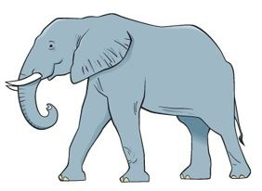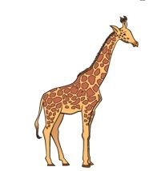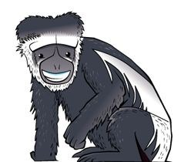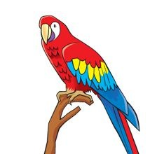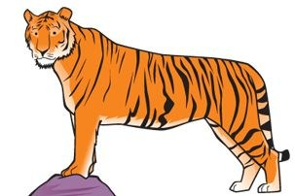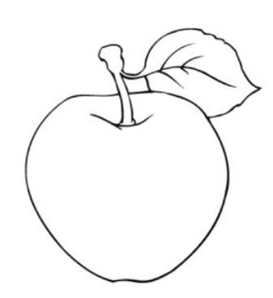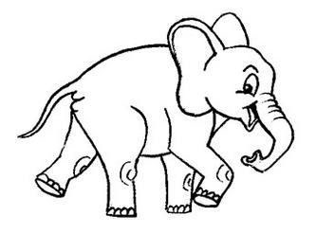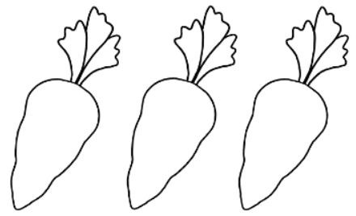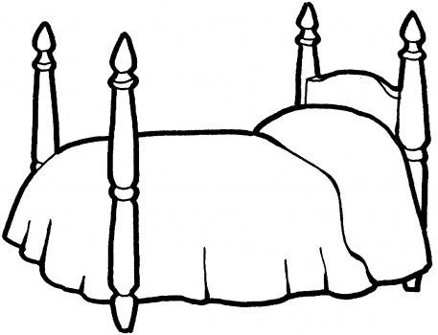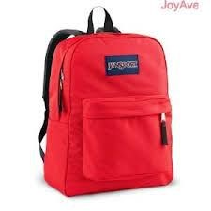
Question
1.
Nghe
v
à
đ
i
ề
n
s
ố
(
1
pt)
Question
2.
Nghe
v
à
t
ô
m
à
u
(
1
pt)
Question
3.
Nghe
v
à
n
ố
i
(
1
pt)
1
1
2
3
5
4
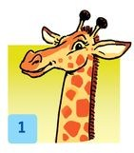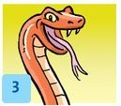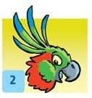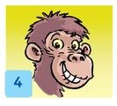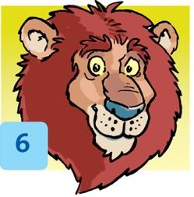
Question 4. Nghe và đánh dấu tích (1 pt):
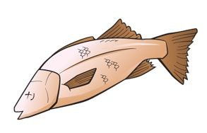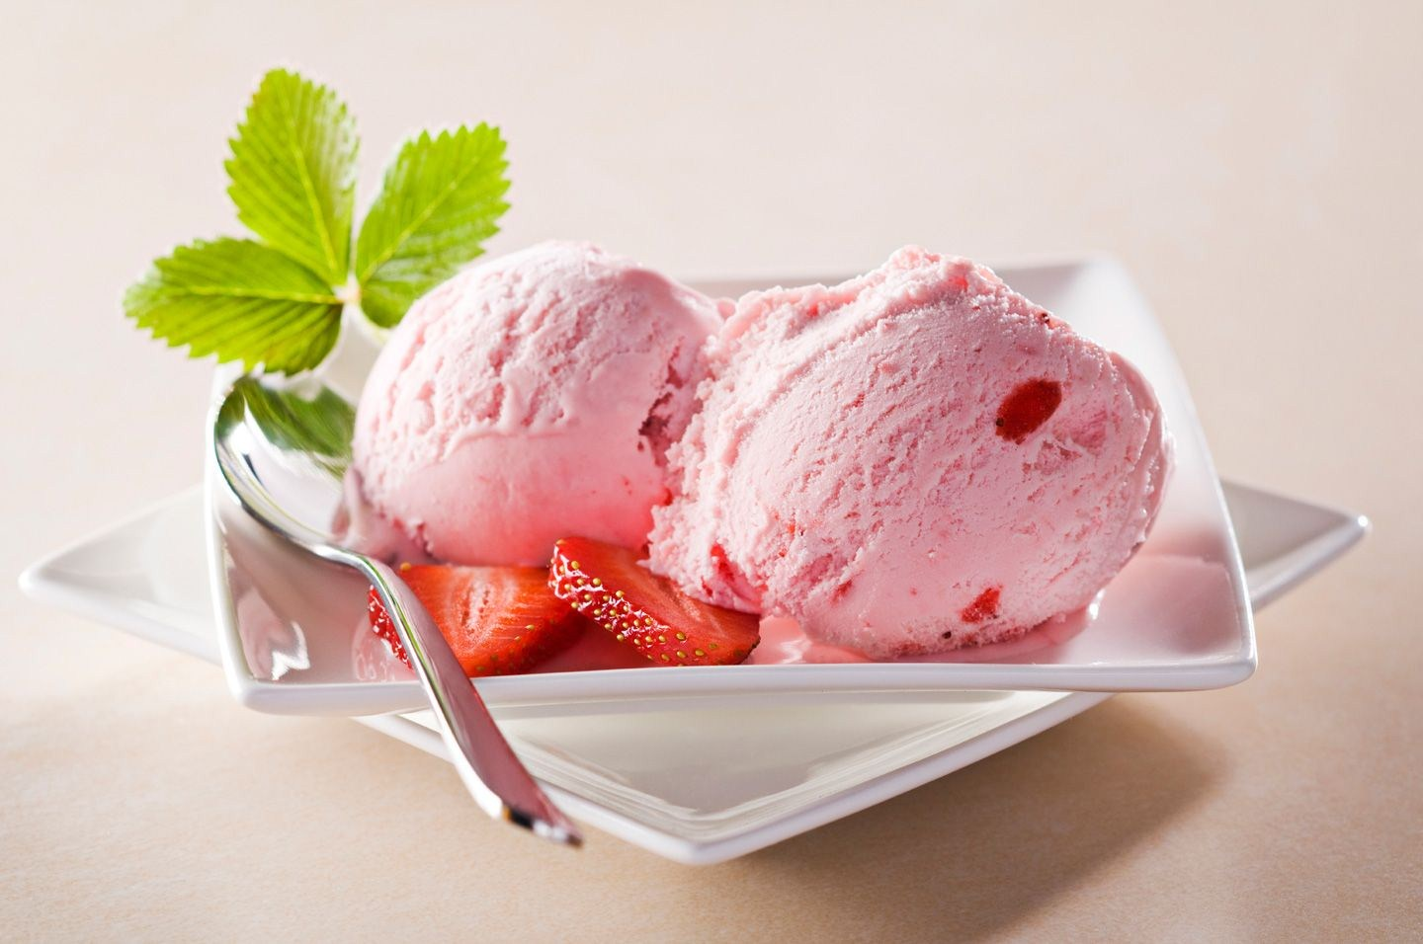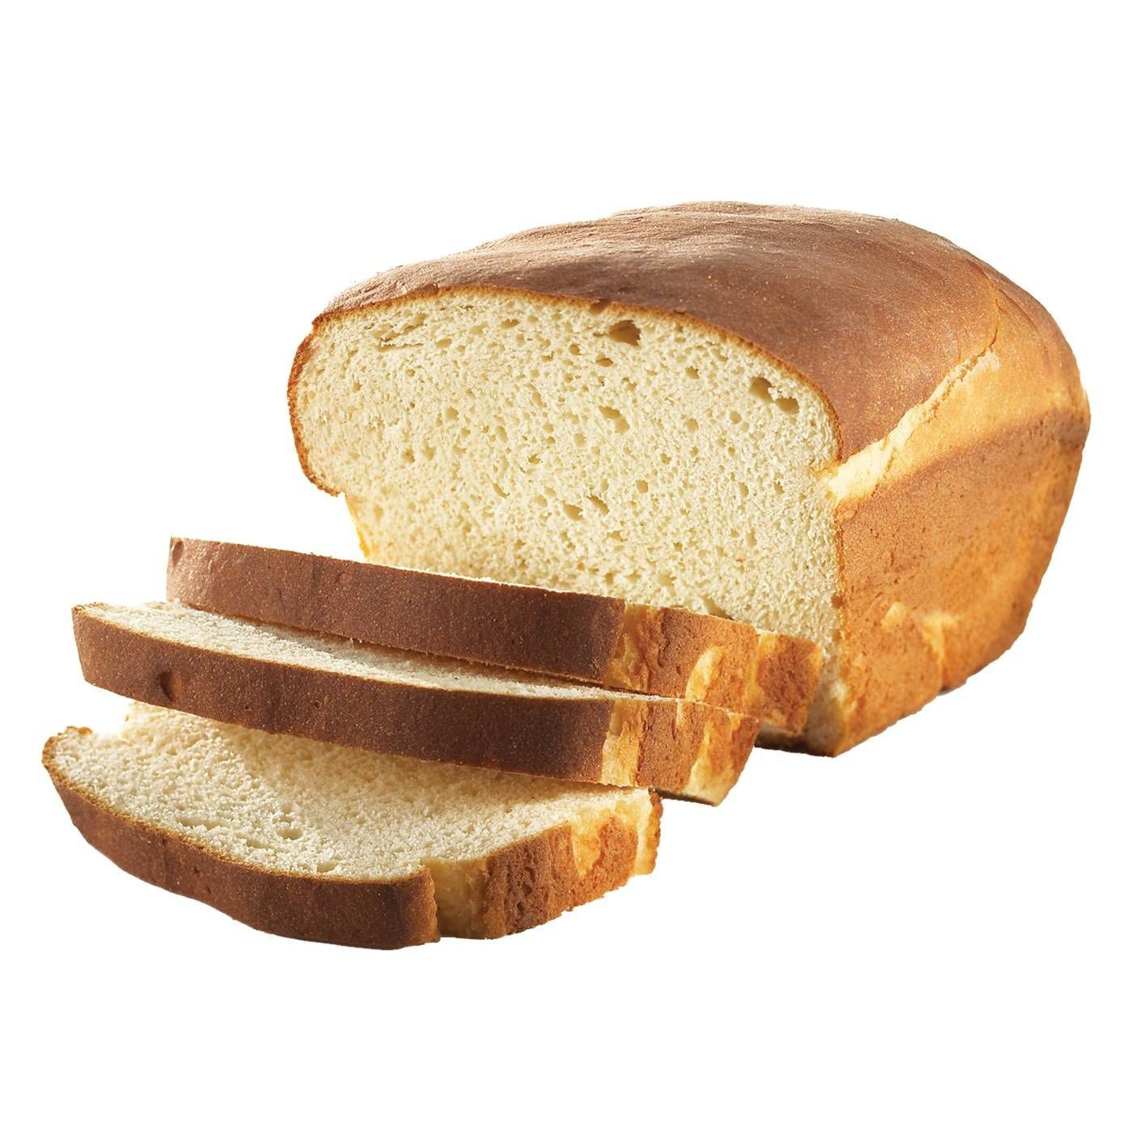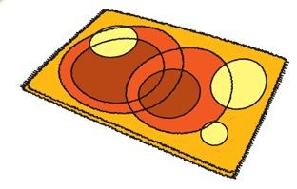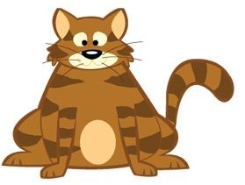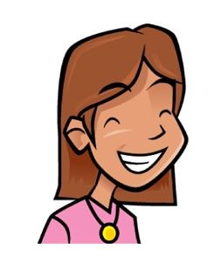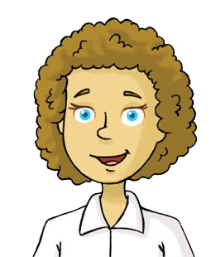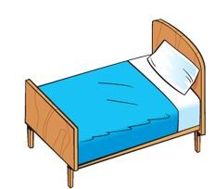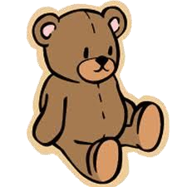
Example
:
1.
2.
3.
4.
5.
Question 5. Nghe và điền từ vào chỗ chấm (1 pt)
  - This is his.................coat
Is he behind the door? No he isn’t.
  - Are you.....................?
We’re brother and sister. We’re cousins.
  - Billy, you like animals.
But you don’t like......................... and you don’t like giraffes.
  - Rice,............. and carrots for Billy.Do you like carrots, Billy?
No, I don’t. No carrots for me!
  - Look,Grandma. My.............. is tidy up now.
Good girl, Rosy. Well done!
PART II: Reading and writing. (15 minutes)
Question 6: Look and read. Put a tick (✓) on the right sentence and a cross (✗) on the wrong sentence.
(Nhìn và đọc. Đánh dấu (vào câu đúng và dấu x vào câu sai) Example:
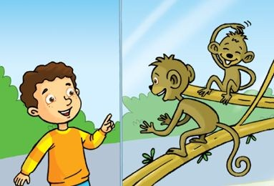
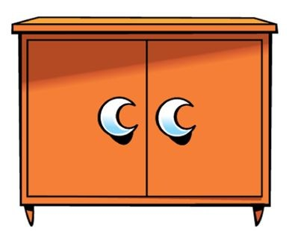
It’s a circle. ☑It’s got four sides. ☒
1.He has got short hair.  2.Thirteen 
3.I like tigers  4.There is a blanket. 
Question 7: Look and read. Write “ Yes” on the right sentence and write “ No” on the wrong sentence. (Nhìn và đọc. Viết Yes hay No vào chỗ trống) Example:
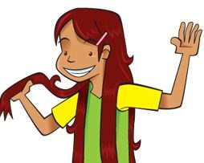 She’s got long hair. Yes She’s got short hair. No
- 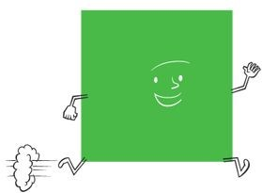 It’s got three sides. ________
- 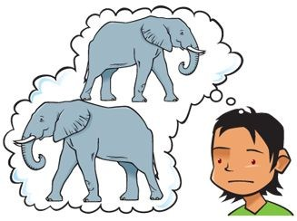 I don’t like giraffes. ________
- 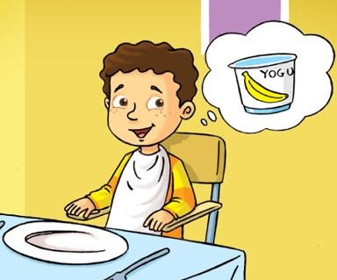 I like yogurt. ________
- 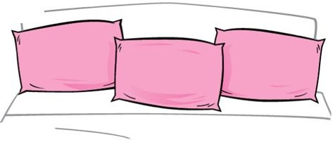 There are three pillows. ________
Question 8: Look at the picture. Look at the words. Write the sentences. (Nhìn tranh. Nhìn các chữ cái, viết thành từ đúng) Example:
I’ve | a pen |  | got |  | .
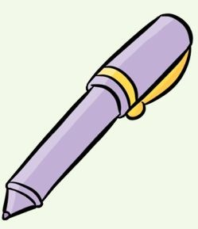 I’ve got a pen.
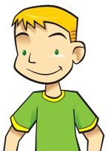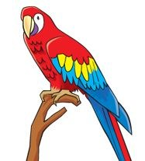 | hair got blond He’s .
 | you Do parrots like ?
1.__________________________________
2.___________________________________
beds |  | There |  | two |  | are |  | .
- 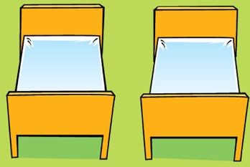 _________________________________
like |  | I |  | ice cream |  | .
- 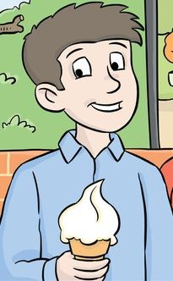 _________________________________
Question 9: Choose the right word/phrases from the box and write them next to numbers from 1 - 4.
(Chọn từ trong khung và điền vào chỗ trống)
milk | tiger | blanket |  | curly hair | carrot
Example:
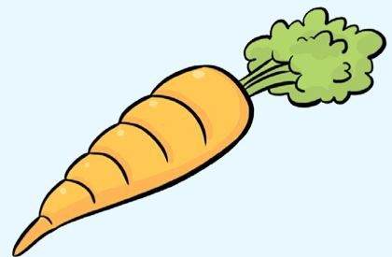
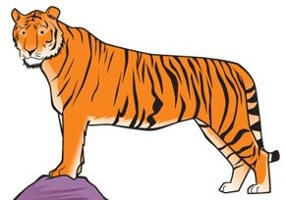
    - carrot
    - _______________ 2. ________________
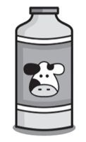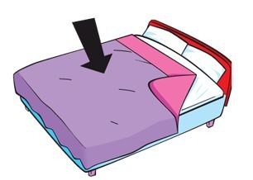
SPEAKING TEST
Part 1: Listen and repeat:
+ Teacher reads or plays the CD, student repeats
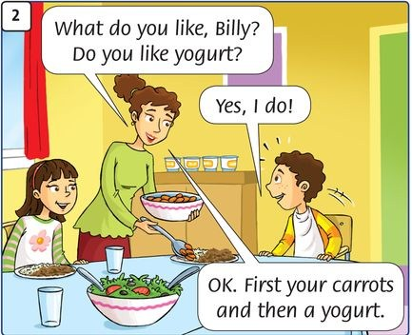
Part 2: Point, ask and answer:
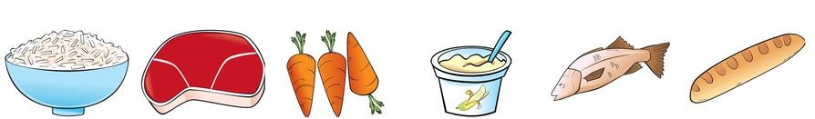
+ Teacher points and asks, student answers
TeacherStudent
  - What do you like?I like yogurt
  - Do you like meat?Yes, I do / No, I don’t.
Part 3: Listen and comment: (Yes or No)
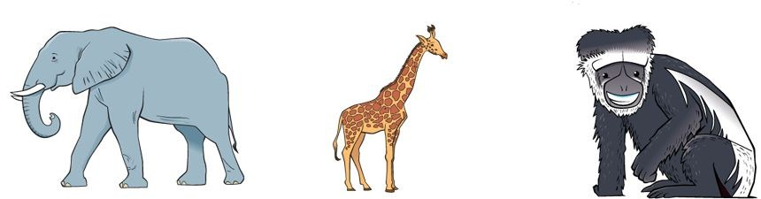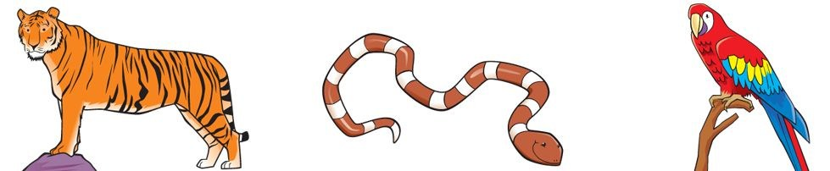
+ Teacher points and says, student replies
TeacherStudent
  - It’s bigYes, it is.
  - It’s littleNo, it isn’t - It’s big.
  - This is an elephantYes, it is.
  - This is a monkeyNo, it isn’t - It’s a giraffe.
  - ........
Part 4: Interview:
+ Teacher asks pupils to work in pairs.
+ Pupils ask and answer with the questions below:
  - What’s your name?
  - How old are you?
  - How are you?
  - What’s this?
  - Do you like....?
  - What do you like?
  - What’s your favorite colour?
  - What’s your favorite toy?
......................
3. _______________ 4. ________________
ANSWER KEY
A. LISTENING
Question 1. | 1. elephant 2. giraffe 3. monkey 4. tiger 5. parrot
Question 2. Question 3. | 1. Bag - red 2. Apple - yellow 3. Elephant - pink
 | 4. Carrots - orange 5. Bed - purple
(Like) | (Dislike)
Giraffes | - Snakes
Parrots Monkeys | - lions
Question 4. | 1. Yogurt 2. Ice cream 3. Bed and teddy | 4. Monkey | 5.Alice
Question 5. | 1. Coat 2. Friends 3. Elephants  ANSWER KEY | 4. Meat | 5.Room
B: READING AND WRITING
Question 6. 1. ☑ 2. ☑ 3. ☒ |  | 4. ☒
Question 7. 1. No 2. No 3. Yes |  | 4. Yes
Question 8. 1. He’s got blond hair. 2. Do you like parrots?
3. There are two beds. 4. I like ice cream.
Question 9. 1. Curly hair 2. tiger 3. milk 4. blanket

